INDIAN SCHOOL AL WADI AL KABIR
TERM 1: Chapter 2- Terms, concepts & their use in Sociology
(GRADE XI)
NOTES AND Q&A

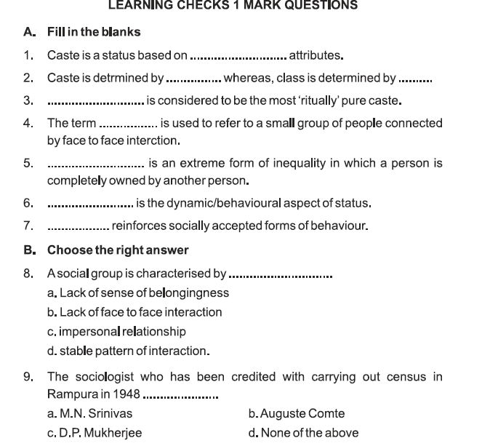

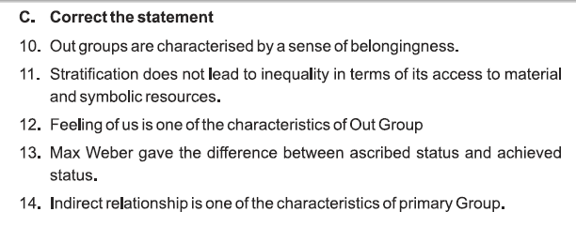
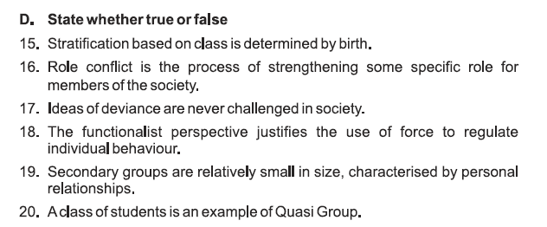

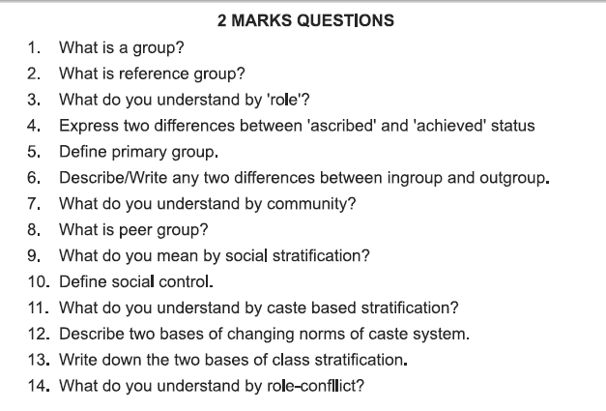
ANSWERS:

- Social groups refer to a collection of continuously interacting persons who share common interests, culture, values and norms within a given society.
- Reference group:
The term ‘Reference group’ was coined by Herbert Hyman. Hyman distinguished between a membership group to which people actually belong to and a reference group which is used as a basis for comparison.
A reference group may or may not be a membership group. A type of group in which we do not belong to but we aspire to be like them and therefore we try to emulate their lifestyle, e.g. for many Indian youths, Americans are a reference group. Reference groups are basis for comparison.
- Role refers to the expected behaviour of an individual who holds a certain status and it is the status which determines the behaviour pattern, obligations and privileges. Role is the dynamic aspect of status. The functions which an individual performs in society are referred to as ‘Role taking’ and the functions that he/she is expected to perform are known as ‘Role expectations’.

4. 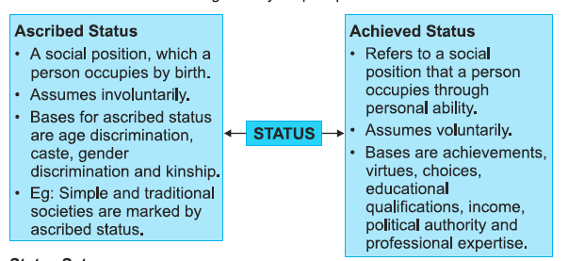
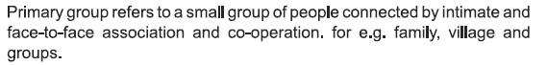
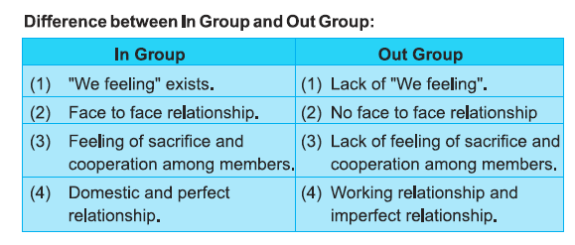
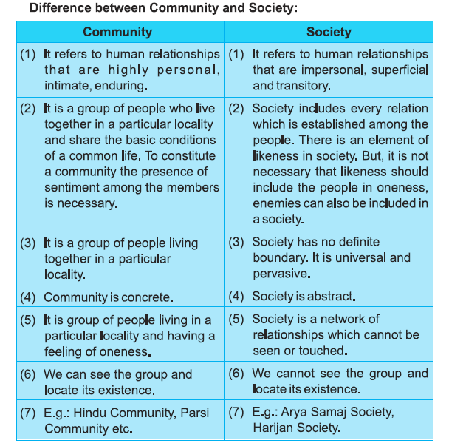
8. Peer group:
A set of individuals who, share certain common characteristics such as age, ethnicity or occupation, perceive themselves and are recognised by others as a distinct social collectivity.
The group is seen to have its own culture, symbols, sanctions and rituals, into which the new members must be socialised according to which those who fail to comply with group norms may be ostracized.
9. Social stratification refers to division of members of a society into different social categories or strata which are ranked into hierarchy, according to their relative power, prestige and wealth. It is not an individual fact, it is rather a social fact.
10. Social control is a process by which stimuli are brought to bear effectively upon same person or group of persons thus producing responses that function in adjustment to the group. Social control means basically the restrictions which a society imposes over its members through various means for effective functioning of social network.
11.
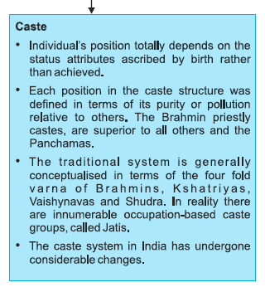
12.
13. Base of class stratification
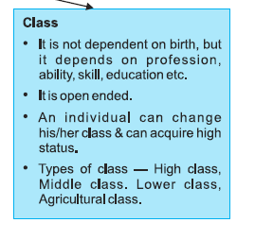
14.
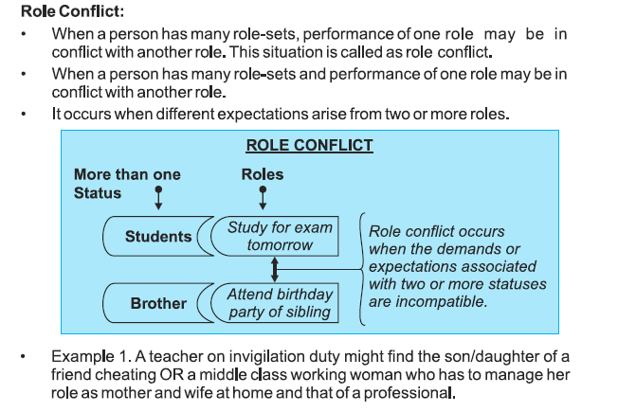
Additional Questions:
Question 1: Define informal group.
Answer: A type of group in which there is complete absence of arrangement and organization. Members of informal groups are attached to each other by friendship, personal relations, emotional bonding and respect for each other.
Question 2 Define in-group.
Answer: The groups having ‘we’ feeling are called ‘in-groups’. Members perceive positive characteristics for each other. The group maintains mutual dependence, trust, solidarity, harmony and sacrifice. Members are cooperative to each other and a lot of communication occurs.
Question 3: Define out-group.
Answer: Out groups are ‘they’ groups. These are stranger groups. Members of ‘in-group’ perecive them with negative characteristics, competition, hostility, lack of communication. For the Congress Party members, the BJP members are Out-group and vice-versa.
Question 4: Define formal group.
Answer: The groups which are arranged and organised. These are large or a part of large organisation. Formal groups are always normative & hierarchal structure in which relationship bonds are professional, e.g. university, army etc.
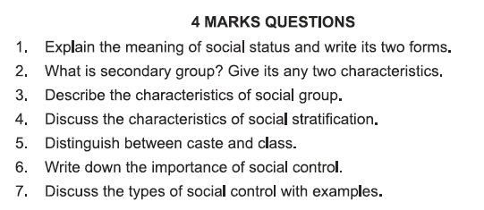

ANSWERS:
- Social status refers to the position that a person occupies in the social structure, such as a teacher or priest. It is often combined with the motion of social role. In its stranger and more specific meaning it refers to a form of social stratification in which social positions are ranked and organised by legal, political and cultural criteria into status groups.
Status, which an individual gets by birth or due to nominations is known as ‘Ascribed Status.’ e.g. Brahmins higher status in Hindu society is simply ‘ascribed’.
Ascribed status is determined by age, sex, birth, caste, kinship, race, class etc.
The bases of ascribed status is usually fixed and the sources of ‘Ascribed Status’ are the customs, traditions, values and norms of the society.
An individual acquires ‘Achieved Status’ because of his intelligence, aptitude, efforts, diligence, skills and personality characterization.
The sources of ‘Achieved Status’ are individual’s own personality traits and his/her ability to make best use of his/her potentials.
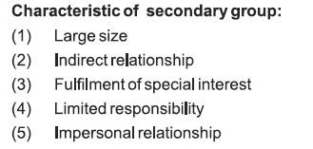
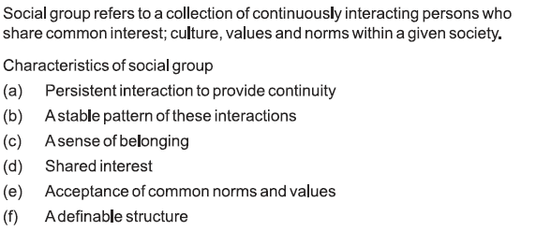
- Social stratification refers to division of members of a society into different social categories or strata which are ranked into hierarchy, according to their relative power, prestige and wealth. It is not an individual fact, it is rather a social fact.
It refers to the ranking of a large number of individuals into hierarchy organized strata.
It has little to do with individual merits/abilities and more to do with socially patterned inequalities.
Major systems of stratification include: caste, class, gender, slavery and estate.
State main functions of stratification.
- Determination of nature of social relations.
- Stratification accelerates the process of social change.
- It is helpful in determining social order and organization.
- Stratification functions as a safety valve from frustrations, conflict and tension because it helps to place the individuals where they actually fit in.
- Social stratification gives rise to division of labour and specialization which helps in social integration.
- Social stratification leads to social progress through the spirit of competitions.
- Caste and class distinction:
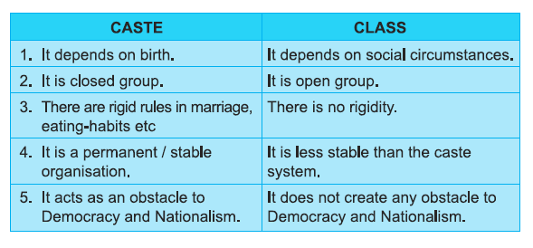

- Importance of Social Control
The term ‘social control’ refers to the social process by which the behaviour of individuals or group is regulated. Society is a harmonious organization of human beings and expected to perform their functions accordingly. In order to exist and progress society has to exercise certain control over its members, such controls are termed as social control. Consequently, social control is pervasive feature of any society.
Social control helps to restrain the unwanted behaviour of the individuals and the groups. It is an influence, exercised by society for promoting the welfare of the group as a whole.
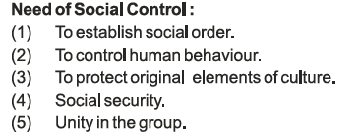
- Types of social control with examples
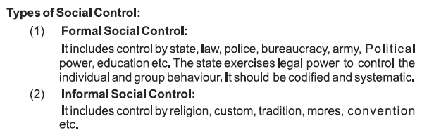
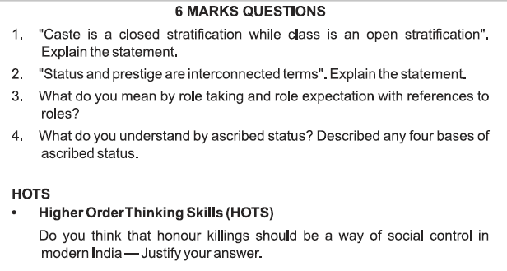
ANSWERS:

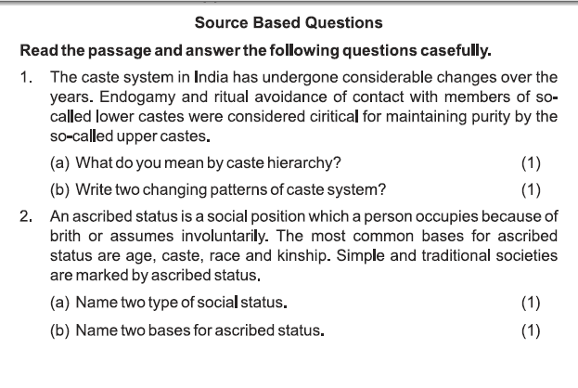
NCERT QUESTIONS:

- Why do we need to use special terms and concepts in Sociology?
Ans: As opposed to commonsensical knowledge, sociology like any other science has its own body of concepts and methods of data collection.
As a social science, sociology does need to have certain agreed upon meanings of social realities and processes in studying. Each subject is required to have a standard vocabulary, terminology, language and concepts through which professionals can converse and maintain the different identity of its subject.
It becomes all the more important to discuss sociological terms so as to distinguish what they mean from commonsensical usage which may have varied meanings and connotations.
2) As a member of society, you must be interacting with and in different groups. How do you see these groups from a sociological perspective?
Ans: Social groups can be defined as an organised structure of two or more persons who interact with one another, have shared goals, are interdependent, and consider themselves as members of a group.
Groups have the following salient characteristics:
- A social unit consisting of two or more individuals who perceive themselves as belonging to the group. This characteristic of the group helps in distinguishing one group from the other and gives the group its unique identity.
- A collection of individuals who have common motives and goals. Groups function either working towards a given goal or away from certain threats facing the group.
- Persistent interaction to provide continuity.
- A stable pattern of interaction.
- Acceptance of common norms and structures.
- A collection of individuals who are interdependent on what one is doing may have consequences for others.
- There is an organised structure by a set of roles, norms, status and cohesiveness.
Sociologists, Anthropologists and Social Psychologists categorised groups into different types:
Primary and Secondary groups
1.Primary groups are pre-existing formations which are usually given to the individual whereas secondary groups are those which the individual joins’ by choice, e.g., family, caste and religion are primary groups, whereas membership of a political party is an example of secondary group.
- In a primary group, there is face to face interaction, members have close physical proximity and they share warm emotional bonds.
- Primary groups are central to individual functioning and have a major role in developing values and ideals of the individual during the early stages of development.
- Secondary groups are those where relationships among members are more impersonal, indirect and less frequent.
- In the primary group, boundaries are less permeable i.e. members do not have the option to choose membership as compared to secondary groups where it is easy to leave and choose another group.
- Primary groups have a sense of belongingness whereas secondary groups are relatively large in size, maintain formal and impersonal relationships e.g. schools, offices, hospitals etc.
2.Formal and informal groups
The functions of the group are stated explicitly and formally in formal groups
The formation of formal groups is based on specific rules or laws and members have
definite roles.
Formal groups differ to informal groups on the basis of structure.
Informal groups are more flexible and members have close relationship.
3.In group – Out group:
The term In-group refers to one’s own group and Out-group refers to another group. For In-group members, we use the word ‘we’ while for Out-group members the word ‘they’ is used.
Persons in the In-group are generally supposed to be similar and viewed favourably and have desirable traits.
Members of this group are viewed differently and are often perceived negatively in comparison to the In-group members.
- We all have a world of our dreams and desires. In sociological perspective, we all live in a social world. We get fascinated and attracted towards a group which might appear to be leading a more fulfilling life. When we look up to other people or groups, we secretly aspire to be like them. We start identifying with them, we internalise their traits, behavioural patterns and actions so that we may like them. Thus, we do not belong to our reference groups, we only identify them.
- Reference Groups:
Newcomb (social psychologist) used reference groups to help explain the changing values and attitudes of students of a liberal women’s college. Many of the women who came from politically conservative background developed increasingly liberal attitudes over the course of their college careers, as they came to identify more with the college faculty and less with their family of origin. The girls who changed most were those characterised by independence from their parents, a sense of personal adequacy in social relations in achieving their goals.
For example, many a time school and college girls and boys who are basically members of students group admire, appreciate and identify with the stars of Bollywood e.g. Sadhna, Rajesh Khanna etc. and develop desire to become like them secretly. They initiate their life style, hair style, talking style, clothes etc. Basically, their membership group is students’ group but they get fascinated with the film stars group which for them is the reference groups.
From sociological perspective if a society has strong healthy role models related to politics, religion, profession etc. as reference group then young generation do get influenced with them accordingly.
Question 3: What are social groups? Discuss various types of groups
Answer: A number of individuals, defined by formal and informal criteria of membership, who share a feeling of unity or are bound together in relatively stable pattern of interaction are called social groups.
Sociology is primarily concerned with social relations and how these relations develop as a result of social interaction. When some people establish social relations with one another, their gathering is called a group. Direct or indirect relations between two or more people is the fundamental basis of a social group. A collection of human beings may be called a group only when it has a permanent set of patterns. The members need to influence one another by their internal activities. When members establish relationships on the basis of common characteristics and goals and influence each other, it is called a group.
Social groups differ in size, ranging from intimate associations, like a family to large collectivities such as a political party. Groups are organised system of two or more individuals. People join groups because they provide security, status, self-esteem, satisfaction of one’s psychological and social needs, goal achievement, knowledge and information. Group formation is a natural process of society. Proximity, similarity and common motives and goals facilitate group formation. Groups are of different types i.e. primary and secondary, formal and informal and ‘in-group’ and ‘out-group’.
Primary groups are preexisting formations in which face to face interaction is possible and relationship bonds are based on personal relationship. In primary groups a person knows one another well and they establish close relationship among them, boundaries are more permeable. Secondary groups are those where relationship among members are more impersonal, indirect and less frequent. In this group it is easy to leave and join another group. Secondary groups provide experience lacking in intimacy.
Formal groups differ in degree to which the functions of the group are stated explicitly and formally. The functions of a formal group are explicitly stated as in the case of an office organisation. The roles to be performed by group members are stated in the explicit manner. The formal and informal groups differ on the basis of structure. The formations of formal groups is based on same specific rules or laws and members have definite roles.
There are a set of norms which help in establishing order.
On the other hand, the formation of informal groups is not based on rules or laws and there is close relationship among members. Formal groups are groups that are arranged and organized e.g. university. Formal groups tend to be large or a part of large organization having a normative hierarchical structure. Informal groups are typically small and casually or spontaneously formed and function without formal rules, goals or leaders.
The term in-group refers to one’s own group, and out-group refers to another group. For in-group members, we use the word ‘we’ group while for out-group members the word ‘they’ group is used. By using the word ‘they’ and ‘we’, one is categorizing people on similar or different basis. It has been found that persons in the in-group are generally supposed to be similar, are viewed favourably, and have desirable traits. Members of the out-group are viewed differently and are often perceived negatively in comparison to the in-group members.
Perceptions of in-group and out-group affect our social lives. Co-operation and proximity are common features of in-group members. Hostile and aggressive relationship leading to conflict and competition is common feature towards out-group members. In-group members maintain mutual dependence, solidarity, faithfulness, friendship, cooperation and communication for members whereas out-groups are known as stranger group.

Question 4: How class stratification is different from caste stratification?
Answer: Class stratification is based on one’s economic and social status (position) whereas caste stratification is determined by birth. Class stratification is open to all but caste stratification prevents other caste members.
Question 5: What have you observed about the stratification system existing in your society? How are individual lives affected by stratification?
Answer: The term ‘stratification’ in sociology is usually applied to studies of structured social inequality i.e. studies of any systematic inequalities between groups of people, which
arise as the unintended consequence of social processes and relationships. When we ask why there is poverty, why Dalits and women in India are disadvantaged, we are posing questions about social stratification.
Social stratification is the core issue of macro sociology, the study of whole society. Social stratification is concerned in different ways with the issues of class and status – group formation as the key to understanding social integration, that is, the extent to which social relationships are cohesive (togetherness) or divisive which in consequence determines social order.
I have observed that stratification system in our society denotes existence of structured inequalities between different groups of Indian society. Indian society consists of a strata in hierarchy i.e. most favoured people at the top and least privileged people at the bottom of the society. Economic disparity leading to class system, caste system, etc. play significant role in stratification in Indian society.
- In Indian caste stratification system, individual’s status is ascribed by birth rather than individual’s achievements and his/her contribution or his/her psychological attributes.
- Against this stratification of Indian society there is a ray of hope. Due to economic growth, constitutional provision, urbanization, industrialization, education, easy communication and enlightened media our society is gradually changing towards betterment.
- Stratification is a natural process of any society. As we know, society is a group. And group is an organized structure in which members have a status role.
- Social stratification gets evolved to ensure that the most important position should be occupied by qualified people.
- The roles refer to expectations which is dynamic and behavioural aspect of status. Status refers to position of each member in the society. The status of any member has an institutionalized role. The role becomes regularized, standardized and formalized in the society.
- Social stratification begins from general assumption or based on the belief of functionalism that no society is classless or without stratification. The only thing required is coordination, balance, integration and development of everyone should be the objective of any healthy society.

Question 6: What is social control? Do you think the modes of social control in different spheres of society are different? Discuss.
Answer: The term ‘social control’ refers to the social process by which the behaviour of individuals or group is regulated. Society is a harmonious organization of human beings and expected to perform their functions accordingly. In order to exist and progress society has to exercise certain control over its members, such controls are termed as social control. Consequently, social control is pervasive feature of any society.
Social control helps to restrain the unwanted behaviour of the individuals and the groups. It is an influence, exercised by society for promoting the welfare of the group as a whole.
Social control varies from one society to another because each society has its own rules and norms. Different types of societies like individualistic society or collectivistic societies have different expectations (roles) from their members.
Indian cultural values and general standards of life are different from western individualistic society, therefore both the societies have different patterns of social control. We emphasize on socialization whereas technologically advanced western society focuses on individual liberty.
Social control considers customs, traditions, rituals, rules and sub rules according to the social demands. Accordingly in that particular society, family system, marriage system, positive and negative conventions, religion and education systems develop. Members of that particular society should conform these systems. Society develops an appropriate social control for that particular society.

